**EXAMPLE 1. Dean Leadership Search**

*This assessment rubric was developed for a Dean search at the University of Washington and has 11 domains/criteria, along with descriptions for each, a scale, and space for additional comments. These criteria should align with the values and goals identified by the search committee as well as the requested materials and descriptions provided in the job ad.*

*Possible scales could include:*

* *No evidence, Unknown, High/Medium/Low evidence (5 options)*
* *Outstanding, Excellent, Good, Fair, Deficient (5 options)*
* *Excellent, Good, Neutral, Fair, Poor, Unable to judge (6 options)*

|  |  |  |  |
| --- | --- | --- | --- |
| **UW College of Arts and Sciences Dean Applicant Assessment Rubric** | | | |
| **Criteria** | **Description** | **Scale** | **Comments** |
| **Demonstrated Leadership** | Has shown visionary leadership for a liberal arts education emphasizing excellence in teaching and research providing a global, national and regional perspective on important trends, innovations, and opportunities in higher education in the 21st Century. |  |  |
| **Evidence of Commitment to Diversity** | Leadership, scholarship and service; have demonstrated capacity to enrich A&S commitment to diversity, equity and inclusion. Candidate’s experience addresses institutional discrimination, race and economic inequity, or complexities of marginalized communities. |  |  |
| **Scholarship and Research** | Has a strong record of high-quality research and distinction in and across discipline. Strong record of knowledge production, grant and or scholarly contributions. Supports/facilitates/promotes faculty and programs that undertake multidisciplinary, cross-disciplinary and community-engaged research. |  |  |
| **Aligns with Core Values of the College** | Shows understanding and commitment to liberal arts education and College priorities. Deeply appreciates the breadth and diversity of the units that comprise the College. |  |  |
| **Serves the Broader University** | Has an external presence that would serve the College and University well. This would include understanding the breadth of contributions, needs, and priorities for the CAS and articulating these effectively to donors, the legislature, the UW community and the wider public in ways that will contribute to the fiscal and programmatic health of the College. |  |  |
| **Demonstrated Expertise in Financial Management** | Is able to harness, steward and strategically manage financial resources and generate new resources. Able to make difficult decisions concerning finances. Understands national dynamics in higher education funding. |  |  |
| **Commitment to Faculty (Governance)** | Will support and empower the faculty through a culture of inclusion, transparency, bi-directional communication and shared governance. |  |  |
| **Commitment to Students** | Will foster student success and encourage student leadership across a large and deeply  diverse student population. Has a demonstrated record of outstanding teaching, service,  and accessibility to students. |  |  |
| **Service and Collegiality** | Has the capacity to collaborate with the Chancellors, Deans, and faculty across the UW  campuses to support and strengthen its vision and values. Has a presence that serves the  College, University, legislative, community, and advancement constituencies with distinction. |  |  |
| **Effective and Relevant Management Experience** | Brings demonstrated success as an effective manager in stewarding achievement of strategic initiatives. Can solve problems and lead in a complex environment. Has the proven capacity to foster a collaborative and collegial environment where staff, faculty and students are positioned for development and success. Can effectively lead change management processes. |  |  |
| **Overall** | Priority to keep applicant in the pool for further review. |  |  |

**EXAMPLE 2. Medical Director Leadership Search**

*This assessment rubric was developed for a faculty leadership role at Seattle Children’s Hospital Center for Diversity and Health Equity for the purposes of initial application reviews by the search committee. There are 4 domains with a 1-4 scale for each accompanied by anchors and examples for each. These anchors were developed through committee discussion, and a “test” application was used to gauge consistency in reviewer ratings. As above, assessment criteria should align with the values and goals identified by the search committee as well as the requested materials and descriptions provided in the job ad. Note that this rubric explicitly identifies the basis for assessment – the candidate’s CV, diversity statement and cover letter.*

**CDHE Medical Director Faculty Search Committee**

**Review of Candidate’s CV, Diversity Statement and Cover Letter**

**CANDIDATE: _______________________________________________________________**

**REVIEWER: ________________________________________________________________**

*Descriptions and examples to consider are given under each category; these are not exhaustive lists.*

Suggested anchors for 1-4 scale:

1: No evidence of work in this category

2: Work in this category is limited to one-time events or in early stages (<1 year)

3: Work in this category is longitudinal, involves service, beyond early stages (>1 year), may be limited in scope to one unit or group

4: Work in this category is longitudinal, well-developed, with clear leadership role(s), has evidence of impact/changed outcomes, with broad reach beyond one unit or group

**CLINICAL EXPERIENCE**  **Low High**

1 2 3 4

*Depth and breadth of clinical work and experiences with diverse populations in a variety of settings; contributions to improving patient- and family-centered care; commitment to high-value, evidence-based care; evidence of clinical expertise and excellence (awards, honors).*

**Comments:**

**COMMITMENT TO EDI AND ANTI-RACISM Low High**

1 2 3 4

*Depth and breadth of experience with communities in under-resourced areas; work and experiences demonstrating commitment to health equity and anti-racist action/praxis with evidence of achieved outcomes; service on committees/work groups to foster EDI; equity-focused advocacy and/or quality improvement; recognition for EDI and/or anti-racism work.*

**Comments:**

**LEADERSHIP AND ADMINISTRATIVE EXPERIENCE**

**Low High**

1 2 3 4

*Service or leadership in institution, community, region and/or national organizations; advocacy work; chief/chair/director positions (educational, research, clinical, or hospital operations) in complex organizations; experience with public speaking/presentations; demonstrated ability to lead and work with interdisciplinary teams to move institutional initiatives forward.*

**Comments:**

**TEACHING AND MENTORSHIP Low High**

1 2 3 4

*Involvement in educational programs and initiatives; mentorship and advising roles; leadership or service in undergraduate medical education, graduate medical education and/or continuing medical education; recognition/awards for teaching/mentoring.*

**Comments:**

**OVERALL RECOMMENDATION: INVITE FOR INTERVIEW?**

YES

MAYBE

NO (must provide comment on your copy of form)

**Comments:**

**EXAMPLE 3. Assistant and Associate Professor Search**

*This rubric is from Harvard University and is designed for assistant and associate professor faculty searches. There are 10 domains and search committees can tailor criteria to reflect an applicant’s “potential for” and/or “evidence of” skills in each domain. This allows reviewers to consider past accomplishment and potential trajectory. Note that this rubric explicitly asks the basis for assessment. Reference:* [*Harvard University, Office of the Senior Vice Provost. Best Practices for Conducting Faculty Searches*](https://hwpi.harvard.edu/files/faculty-diversity/files/best_practices_for_conducting_faculty_searches_v2.0.pdf)*.*

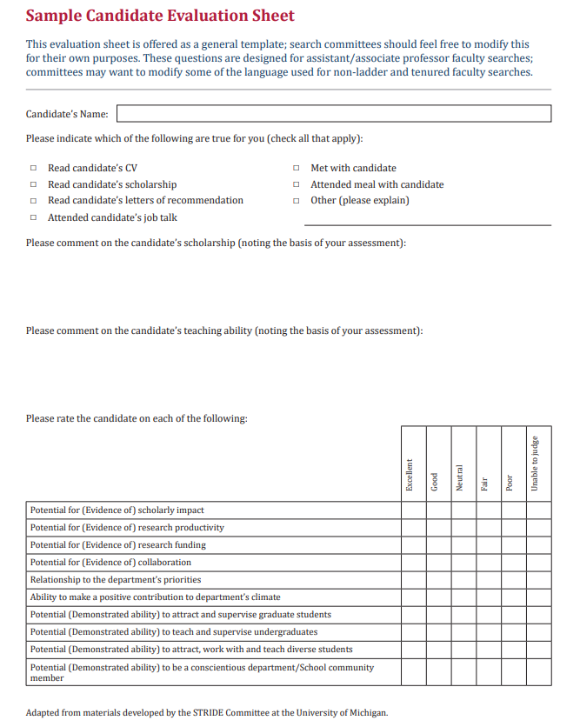

**EXAMPLE 4. Clinician Educator/Clinician Scholar Search**

*This assessment rubric is for applicants interviewing for clinician scholar/clinician educator faculty positions. There are 5 domains and an overall assessment score with a 1-5 scale based on presence or absence of evidence in each domain. As above, assessment criteria should align with the values and goals identified by the search committee as well as the requested materials and descriptions provided in the job ad.*

**FACULTY CANDIDATE INTERVIEW EVALUATION**

**CANDIDATE:** _______________

**DATE:** _____________________

**POSITION/TRACK:** __________________

**DIVISION:**__________________________

**REVIEWER:** ________________________

|  |  |  |  |  |  |  |
| --- | --- | --- | --- | --- | --- | --- |
|  | **1** | **2** | **3** | **4** | **5** | **N/A** |
| Evaluate candidate on a scale of 1 to 5: | Very strong evidence skill not present | Strong evidence skill not present | Some evidence skill is present | Strong evidence skill is present | Very strong evidence skill is present | Insufficient evidence for or against skill |

|  |  |  |
| --- | --- | --- |
| **CANDIDATE COMPETENCIES** | **SCORE** | **COMMENTS** |
| **Research** | | |
| Quality of scientific inquiry |  |  |
| Ability to fund research |  |  |
| Match with resources at UW |  |  |
| Potential for, or evidence of, scholarly productivity (e.g., publications and presentations) |  |  |
| **Clinical Skills** | | |
| Knowledge of clinical medicine including complex care |  |  |
| Patient and family focus |  |  |
| Ability to work collaboratively on an interdisciplinary team |  |  |
| **Teaching and Mentoring** | | |
| Ability to mentor learners |  |  |
| Evidence of effective teaching skills |  |  |
| Ability to tailor educational approach to meet the needs of learners |  |  |
| **Leadership and Teamwork Skills** | | |
| Ability to fulfill professional duties |  |  |
| Ability to lead change |  |  |
| Engagement in continuous improvement |  |  |
| **Diversity Contributions** | | |
| Commitment to Diversity, Equity and Inclusion |  |  |
| Ability to foster an inclusive environment for learning |  |  |
| **Assessment** | | |
| Overall Assessment |  |  |
| Potential Concerns? | |  |

**I recommend [appointment/advancement to the next stage] of this candidate:  Yes  No**